EXP 3: STEPPER MOTOR USING AT89C51 USING PROTEUS
AIM:
To write an assembly language program for Stepper Motor Using AT89C51 using Keil and Proteus
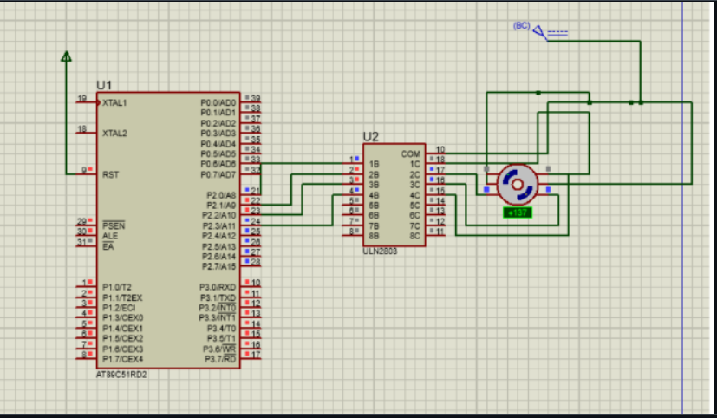

RESULT:
Thus the program has been successfully verified and executed.

